**SOUND CLASSIFICATION FOR RESPIRATORY DISEASES USING MACHINE LEARNING TECHNIQUE**

**Dakshna Moorthy P1, Harikrishna M2, Jude Mathew3, Prof. Sathish N4**

*1, 2, 3 UG Student, Dept. of Computer Science, Panimalar Engineering College, Chennai, Tamil Nadu, India*.

*4 Assistant Professor, Dept. of Computer Science, Panimalar Engineering College, Chennai, Tamil Nadu, India*.

---------------------------------------------------------------------***---------------------------------------------------------------------

**Abstract -** *Respiratory sounds are one of the important signs of lung health and respiratory disorders. These respiratory sounds can be acquired using digital stethoscopes and other recording devices. This advanced information opens up the chance of utilizing artificial intelligence to naturally analyze respiratory scatters like asthma, pneumonia and bronchiolitis, to give some examples. A very high number of people lose their lives to different respiratory diseases every day. Respiratory Sound Analysis has been a key tool to accurately detect these types of diseases. Earlier manual detection of respiratory sounds was used but it is not feasible to detect various lung diseases due to various reasons like audio quality and perceptions of different doctors. Modern computer aided analysis helps to give much better results in identifying the diseases from the sound that includes identification of Wheezes and Crackles in the audio and thus better treatment can be given to patients. These respiratory sound diseases include Asthma, Bronchitis, Pneumonia, COPD (Chronic Obstructive Pulmonary Disease), LRTI (Lower Respiratory Tract Infection), and URTI (Upper Respiratory Tract Infection).*

***Key Words*: Lung diseases, Digital stethoscopes, Sound analysis, Artificial Intelligence, Wheezes, Crackles**

**1. INTRODUCTION**

The classification and identification of breathing diseases is a tedious task. The sound that is produced when a person breathes is directly associated with the movement of air, variations in the lung tissue and the position of the secretions inside the lung. A wheezing sound is an example for a person with obstructive disease like asthma or Chronic Obstructive Pulmonary Disease (COPD). One of the major causes of mortality and morbidity worldwide is respiratory diseases. It developed the third prominent cause of death in 2020. Asthma is also related to COPD, but the definition is different. This disease also results in social and economic burden that is both substantial and increasing. The important treatment outcomes of COPD are symptoms, acute exacerbations and limitations of airflow. Interestingly, the Sounds from the lungs conveys significant information associated with respiratory diseases and it helps to assess the patients with pulmonary or respiratory disorders. Sounds released from a person’s breath are

directly related to changes in lung tissue, position of secretion within the lungs and air movement. For instance, wheezing sound is a common indication that the patients have diseases like obstructive airway disease (asthma and chronic obstructive pulmonary disease).The most important objective of the research is to detect and categorize the lung noise digital signal with the help of signal learning processing methods. An electronic stethoscope overcomes the low sound levels by electronically amplifying the body sounds. Electronic stethoscopes convert the acoustic sound waves obtained through the chest piece into electrical signals which may then be amplified for optimal listening. Recording equipment includes AKG C417L Microphone, 3M Littmann Classic II SE Stethoscope, 3M Littmann 3200 Electronic Stethoscope, WelchAllyn Meditron Master Elite Electronic Stethoscope. In this paper we are focusing on the respiratory sound classification and prediction using machine learning algorithm (Decision Tree Classifier).We use the python as a background for our development of the system as it gives more functionality for data analysis.

**2. LITERATURE SURVEY**

[1] The stethoscope and its semantic of auscultatory findings were invented 200 years ago by Dr. Laennec and over the years only a fewchanges weremade to both the stethoscope the way during which it is used. However, the processto distinguish between normal and abnormal sounds or noises (vesicular sounds, wheezes, crackles, etc.) remains essential in clinical practice for prope**r** diagnosis and management. It aims to review recent technological advances, evaluate promising innovations and perspectives within the field of auscultation, with a specialintelligent communicating stethoscope systems in clinical practice, and within thecontext of teaching and telemedicine

[2] Identification of normal and abnormal respiratory sounds such as crackles, wheezes is very essential for accurate diagnosis of diseases. These sounds include a lots of information about the pathologies and physiologies of lung structure and any obstruction in airways can be identified from the sounds

[3] Various studies were done, and research was made to test human ears' capacity to identify crackles. The research consisted of crackles simulated to superimpose as real respiratory/breathing sound. The most important detection errors were identified from these research like intensity of crackles, different types of crackles make different wavelengths and so on. From these studies we could conclude that traditional auscultation should not be considered as individual reference for validating respiratory sounds.

**3. EXISTING SYSTEM**

The existing system mainly focus on the finding the respiratory sounds that has the potential to detect abnormalities in the early stages of a respiratory dysfunction and thus enhance the effectiveness of decision making. However, the existence of a publically available large database, in which new algorithms can beimplemented, evaluated, and compared, is still lacking and is vital for further developments in the field. The recordings were collected using heterogeneous equipment and their duration ranged from 10 to 90 s. The chest locations from which the recordings were acquired was also provided. Some disadvantages are method is costly, can be used only to predict only 2 respiratory lung diseases, noise level is high, frequently the x-rays need to be taken for prediction.

**4. PROPOSED SYSTEM**

The proposed method uses the identification of the respiratory disease with the help of the datasets that consists of the people with breathing problems. It identifies and tells us the exact respiratory problem that occurs for the individuals. The prediction is exact and the algorithm used are efficient in finding the respiratory disease. This helps in knowing the problem prior to the last stage.

**5. MODULES**

**5.1 Data collection and audio segmentation**

In this module the data is collected in the form of audio, these audio files are stored and they are converted in the form of a text file, this is how the data is collected. These data are collected from different patients' lungs and it is recorded. Also the patient’s age, gender, BMI (Body Mass Index), height and weight are collected.

**5.2 Preprocessing and cleaning**

Data preprocessing involves the transformation of the raw dataset into a readable format. The data preprocessing

methods directly affect the outcomes of any analytic algorithm. These data are pre-processed and we have to clean the unwanted and all null values.

**5.3 Implementation of algorithm**

In this section we are implementing a system for respiratory sound classification and prediction using decision tree classifier algorithm. Several python libraries are used such as numpy, pandas, sklearn, and flask for developing web application.

**5.4 Respiratory disease classification**

In this module it will classify whether the person is healthy or infected. It gives either of these as a result. If the person is infected it will identify the type of disease and display the disease name else it will display the person is normal.

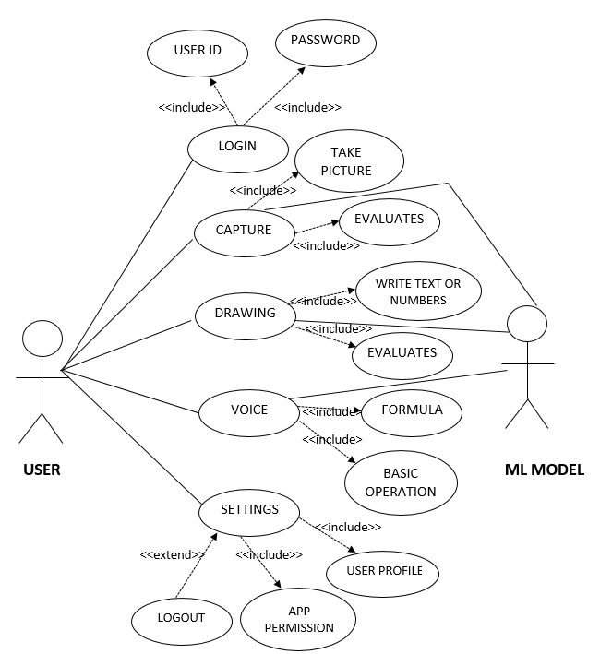

**Fig 1: UML Diagram for the system**

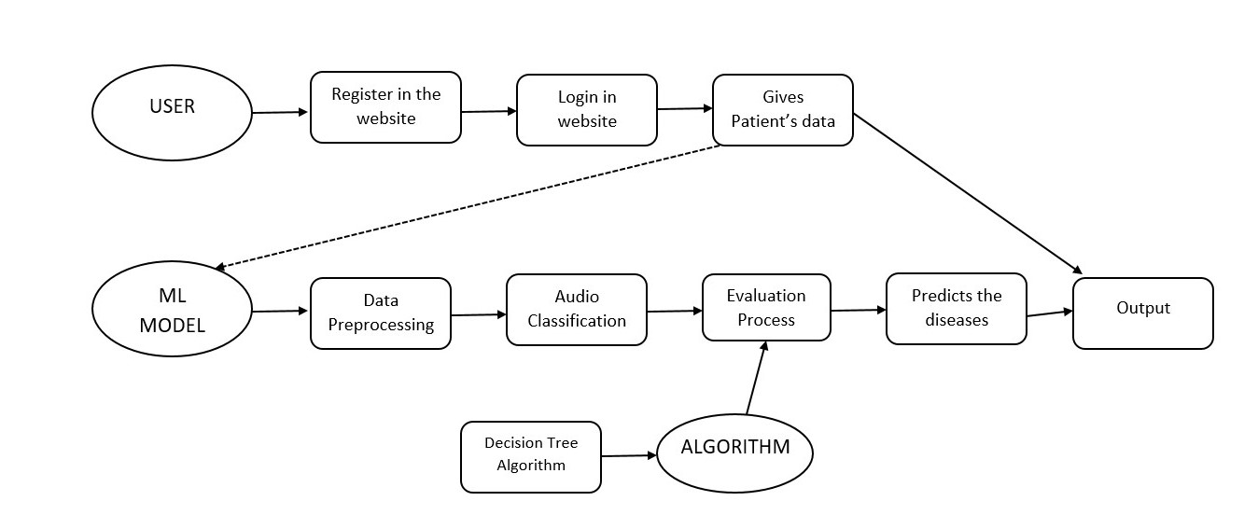

**Fig 2: Flow Diagram**

**6. HARDWARE REQUIREMENTS**

|  |  |
| --- | --- |
| HARD DISK | > 90 GB |
| PROCESSOR | >Core i3 2.4GHz |
| SYSTEM TYPE | 32bit / 64 bit |
| RAM | >2GB |

**7. SOFTWARE SPECIFICATION**

**7.1 Anaconda**

Anaconda is a [distribution](https://en.wikipedia.org/wiki/Software_distribution) of the [Python](https://en.wikipedia.org/wiki/Python_(programming_language)) and [R](https://en.wikipedia.org/wiki/R_(programming_language)) programming languages for [scientific computing](https://en.wikipedia.org/wiki/Scientific_computing) ([data science](https://en.wikipedia.org/wiki/Data_science), [machine learning](https://en.wikipedia.org/wiki/Machine_learning) applications, large-scale data processing, [predictive analytics](https://en.wikipedia.org/wiki/Predictive_analytics), etc.), that aims to simplify [package management](https://en.wikipedia.org/wiki/Package_management) and deployment. The distribution includes data-science packages suitable for Windows, Linux, and macOS. [4]

**7.2 Python**

Python is an [interpreter](https://en.wikipedia.org/wiki/Interpreted_language), [high-level](https://en.wikipedia.org/wiki/High-level_programming_language) and [general-purpose programming language](https://en.wikipedia.org/wiki/General-purpose_programming_language). Python's design philosophy emphasizes [code readability](https://en.wikipedia.org/wiki/Code_readability) with its notable use of [significant indentation](https://en.wikipedia.org/wiki/Off-side_rule). Its [language constructs](https://en.wikipedia.org/wiki/Language_construct) and [object-oriented](https://en.wikipedia.org/wiki/Object-oriented_programming) approach aim to help [programmers](https://en.wikipedia.org/wiki/Programmers) write clear, logical code for small and large-scale projects. Python is dynamically-typed and garbage-collected. It supports

multiple programming paradigms, including structured (particularly, procedural), object-oriented and functional programming.[5]

**7.3 Flask**

Flask is a micro [web framework](https://en.wikipedia.org/wiki/Web_framework) written in [Python](https://en.wikipedia.org/wiki/Python_(programming_language)). It is classified as a [micro framework](https://en.wikipedia.org/wiki/Microframework) because it does not require particular tools or libraries. It has no database abstraction layer, form validation, or any other components where pre-existing third-party libraries provide common functions. However, Flask supports extensions that can add application features as if they were implemented in Flask itself. [6]

**7.4 Scikit-learn**

Scikit-learn is a [free software](https://en.wikipedia.org/wiki/Free_software) [machine learning](https://en.wikipedia.org/wiki/Machine_learning) [library](https://en.wikipedia.org/wiki/Library_(computing)) for the [Python](https://en.wikipedia.org/wiki/Python_(programming_language)) [programming language](https://en.wikipedia.org/wiki/Programming_language). It features various [classification](https://en.wikipedia.org/wiki/Statistical_classification), [regression](https://en.wikipedia.org/wiki/Regression_analysis) and [clustering](https://en.wikipedia.org/wiki/Cluster_analysis) algorithms including [support vector machines](https://en.wikipedia.org/wiki/Support_vector_machine), [random forests](https://en.wikipedia.org/wiki/Random_forests), [gradient boosting](https://en.wikipedia.org/wiki/Gradient_boosting), [*k*-means](https://en.wikipedia.org/wiki/K-means_clustering) and [DBSCAN](https://en.wikipedia.org/wiki/DBSCAN) (Density-Based Spatial Clustering of Applications with Noise), and is designed to interoperate with the Python numerical and scientific libraries [NumPy](https://en.wikipedia.org/wiki/NumPy) and [SciPy](https://en.wikipedia.org/wiki/SciPy). [7]

**7.5 Werkzeug**

Werkzeug is a comprehensive WSGI (Web Server Gateway Interface) web application library. It began as a simple collection of various utilities for WSGI applications and has become one of the most advanced WSGI utility libraries. [8]

**8. EXPLANATION**

The base idea is to create a web application for the prediction of respiratory diseases. Initially the patient’s data and their corresponding respiratory sounds are collected using various digital stethoscopes. The respiratory sounds are in .wav format that are observed at several patient’s chest locations such as Trachea, Anterior, Posterior, Lateral. The data files are read which gives the demographic information, patient details and combine them to create a new preprocessed data. At the first we check the total number of the missing values.

Once we get the total missing values, we eliminate any rows that have 3 missing values or more. After the missing values are removed, from the data available for us the Body Mass

Index of the patient is not available for some patients we use the mean of the BMI to add the missing data’s to the rows. Once the missing data is handled, we now read the information audio from the txt file corresponding to each audio file and it creates two data frames one with

information on file naming and other with the information from the file itself. Now the total number of crackles and wheezes are summed for all the respiratory seconds and these are converted into seconds. For prediction we are using Supervised Machine learning i.e. decision tree classifier algorithm. The steps that were followed to execute the algorithm are: We import the decision tree classifiers from the sklearn.tree. Then the decision tree classifier is with a random state 42 with criterion entropy and a maximum depth value is set to 3.The training data is fit to the decision tree classifier using the fit().In our web application the users are asked first to register and create login credentials for them. The users are given two options to check the diseases. In the first option the user can input the crackles and wheezes number along with age, gender and body mass index to get the result. The second option is to upload the sound file where the user can get the result from the audio file.

**9. CONCLUSION**

In this system, we have predicted respiratory diseases from the respiratory sounds database using decision trees. In the preprocessing, we are handling the missing data, normalizing the values and eliminating any unwanted data from our dataset and creating a new preprocessed data. The prediction with decision trees gives an accuracy rate of 90 percent.

**10. FUTURE ENHANCEMENTS**

The future work of the application consists of mostly collecting more data and trying to implement the model with higher accuracy. Also instead of manual annotation of the audio files, teach the model to automatically annotate the recordings. This web application can add storage functionalities where the users can access their previous breath sound checks and also the automatic annotation process of sounds which helps the users to easily identify the disease. A desktop or mobile application can also be built to make the process easier for the users.

**11. REFERENCES**

[1] Andrs, E. (2012) ‘Advances and Perspectives in the Field of Auscultation, with a Special Focus on the Contribution of New Intelligent Communicating Stethoscope Systems in Clinical Practice, in Teaching and Telemedicine’. In Hajjam El Hassani,A. (ed.) EHealth and Remote Monitoring. InTech.

[2] Sandra Reichert, Gass Raymond, Christian Brandt, Emmanuel Andres ‘Analysis of Respiratory Sounds: State of the Art’. Clinical Medicine. Circulatory, Respiratory and Pulmonary Medicine.

[3][H Kiyokawa](https://pubmed.ncbi.nlm.nih.gov/?term=Kiyokawa+H&cauthor_id=11399719), [M Greenberg](https://pubmed.ncbi.nlm.nih.gov/?term=Greenberg+M&cauthor_id=11399719), [K Shirota](https://pubmed.ncbi.nlm.nih.gov/?term=Shirota+K&cauthor_id=11399719), [H Pasterkamp](https://pubmed.ncbi.nlm.nih.gov/?term=Pasterkamp+H&cauthor_id=11399719) ‘Auditory detection of simulated crackles in breath sounds’ Chest. 2001 Jun; 119(6):1886-92.

[4]https://en.wikipedia.org/wiki/Anaconda_(Python_distribution)

[5]<https://en.wikipedia.org/wiki/Python_(programming_language)>

[6] https://en.wikipedia.org/wiki/Flask_(web_framework)

[7] https://en.wikipedia.org/wiki/Scikit-learn

[8] https://palletsprojects.com/p/werkzeug/